What have you done so far? (Group)

Mind maps, Kanban, Target Audience and the Questionnaire.

What needs to be completed next? (Group)

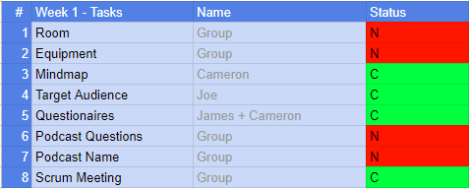

What is your job after this meeting? (Individual)

Joseph -

Find a room to record the podcast as well as equipment. Then think up of question to ask while hosting.

Cameron -

Find a room to record the podcast as well as equipment. Then think up of question to ask while hosting.

James -

Find a room to record the podcast as well as equipment. Then think up of question to ask while hosting.

What have you completed at the end of today’s session? What do you need to complete before the next meeting? (Individual and Group)

We should all have found a room to record the podcast as well as equipment. Individually we should have thought of the questions we are going to ask by next week.